Feelings Reflection
Date of reflection: Date of incident: Student: Adult:
What happened?

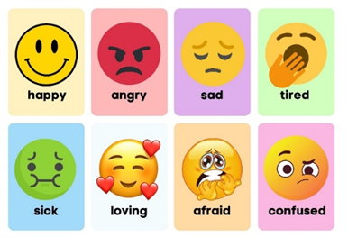
How did you feel?

What could you do next time?

How do you feel now?

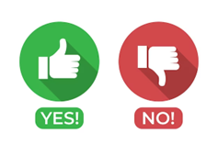
Are you ready to return to the group?

